Vectors and the Parallelogram Rule W.S.

When vectors A and B are at an angle to each other, they add to produce the resultant C by the parallelogram rule. Note that C is the diagonal of a parallelogram where A and B are adjacent sides. Resultant C is shown in the first two diagrams, a and b.
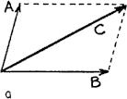
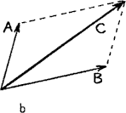

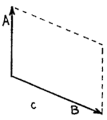
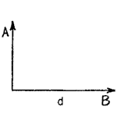
Refer to the following information for the next two questions.

1. Construct the resultant C in diagrams c and d. Note that in diagram d you form a rectangle (a special case of a parallelogram). After you have finished your constructions, state in the blanks which resultant is the longer and which one is shorter.

c.

d.

Refer to the following information for the next two questions.

- Below we see a top view of an airplane being blown off course by wind in various directions. Use the parallelogram rule to show the resulting speed and direction of travel for each case.
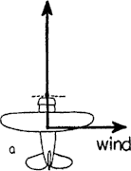
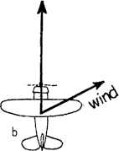
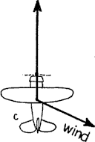
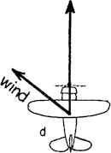

- In which case does the airplane travel fastest across the ground?

a | b | c | d

- In which case does the airplane travel slowest across the ground?

a | b | c | d

Refer to the following information for the next three questions.

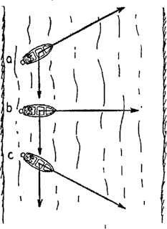
- Below, on the right, we see top views of 3 motorboats crossing a river. All have the same speed relative on the water, and all experience the same flow. Construct resultant vectors showing the speed and direction of the boats.

- Which boat takes the shortest path to the opposite shore?

a | b | c

- Which boat reaches the opposite shore first?

a | b | c

- Which boat provides the fastest ride?

a | b | c

Refer to the following information for the next four questions:

- Circle the vector (A-H) that best represents the resultant of each pair of vectors. Notice in the “choices table” that the resultant vector is in the row above it’s letter!
A | B

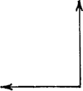

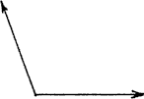

C | D
E | F
G | H

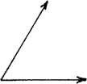

- Match the vector (A-H) that best represents the resultant of each pair of
vectors. Remember in the "choices table" that the resultant vector is in the row above its letter!

A | B
C | D

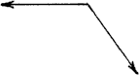

E | F
G | H

- Match the vector (1-8) that best represents the components of each vector. Notice in the “choices table” that the components are in the row above their number!
1 | 5
2 | 6
3 | 7

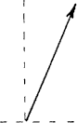

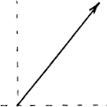

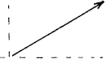

4 | 8

- Match the vectors (9-16) that best represents the components of each vector. Notice in the “choices table that the components are in the row above their number!
9 | 13
10 | 14
11 | 15

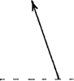

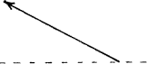
12 | 16

REVIEW NOTES:
 | s-t | v-t | a-t
instantaneous  position | y-coordinate of point | - - - | - - -
displacement | difference in two y- coordinates | area between graph and x-axis | - - -
instantaneous  velocity | slope of tangent (to the graph) at specified time | y-coordinate of point | - - -
change in velocity | - - - | difference in two y- coordinates | area between graph and x-axis
instantaneous acceleration | - - - | slope of graph at specified time | y-coordinate of point

- REVIEW: Refer to the following information for the next nine questions:

Use the given position-time, velocity-time, and acceleration-time graphs to determine the missing values for position, P, and the final velocity, v.
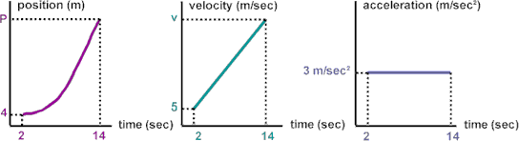

- True or False? The cart in the above graphs is traveling in a positive direction.

True | False

- True or False? the cart is experiencing a constant positive acceleration.

True | False

- What is the cart's initial speed?

- What is the cart's initial position?

- How much did the cart's velocity change from 2 to 14 seconds?

- What is the cart's final velocity at 14 seconds?

- How fast was the cart traveling at 8 seconds?

- How far did the cart travel between 2 and 14 seconds?

- What is the cart's final position at 14 seconds?

REVIEW: Refer to the following information for the next seven questions:

Use the given position-time, velocity-time, and acceleration-time graphs to determine the missing values for position, P, and the final velocity, v.
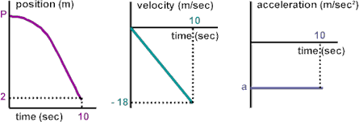

  - True or False? The cart in the above graphs is traveling in a positive direction.

True | False

  - True or False? The cart is experiencing a constant positive acceleration.

True | False

  - What is the cart's acceleration?

d.What is the change in the cart's velocity?

e. True or False? The chart is losing speed.

True | False

f. What is the total distance that the cart traveled?

What is the value of P?

REVIEW: Refer to the following information for the next six questions:

Use the given position-time, velocity-time, and acceleration-time graphs to determine the missing values for position, P, and the final velocity, v.

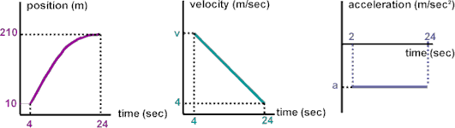

  - True or False? The cart in the above graphs in traveling in a positive direction.

True | False

  - True or False? The cart is experiencing a constant positive acceleration.

True | False

  - What is the cart's displacement?

  - Write an expression for the displacement using the areas under the v-t graph.

  - What is the value of the cart's initial velocity, v?

  - What is the cart's acceleration?

REVIEW: Refer to the following information for the next three problems:

Use the given position-time, velocity-time, and acceleration-time graphs to determine the missing values for position, P, and the acceleration, a.

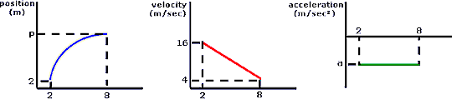

  - P =

  - ∆v =

  - a =
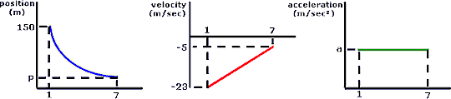
12. REVIEW: Refer to the following information for the next three problems.

Use the given position-time, velocity-time, and acceleration-time graphs to determine the missing values for position, P, and the acceleration, a.

a.
P =

b. Δv =

c. a =
13. REVIEW: Refer to the following information for the next three problems.

Use the given position-time, velocity-time, and acceleration-time graphs to determine the missing values for position, P, and the acceleration, a.

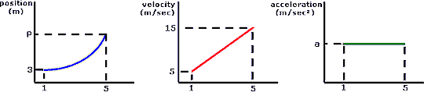

- P =

- Δv =

- a =
14. REVIEW: Refer to the following information for the next three problems.

Use the given position-time, velocity-time, and acceleration-time graphs to determine the missing values for position, P, and the acceleration, a.

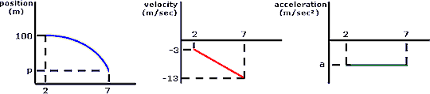

  - P =

  - Δv =

  - a =

